Birla Institute of Technology & Science, Pilani
Work Integrated Learning Programmes Division
Second Semester 2024-2025

Mid-Semester Test
(EC-2 Regular)

Course No. : DE ZG561
Course Title : Mechanisms and Robotics
Nature of Exam : Closed Book
Weightage : 30%
No. of Pages = 3

No. of Questions = 7
Duration : 2 Hours
Date of Exam :
Note to Students:
- Please follow all the Instructions to Candidates given on the cover page of the answer book.
- All parts of a question should be answered consecutively. Each answer should start from a fresh page.
- Assumptions made if any, should be stated clearly at the beginning of your answer.
Q.1 | How is the load carrying capacity related to selecting a robot for a given application? What is the impact of the mass of the end effector? | [3]
Q.2 | The petrol tank of a motorcycle must be spray painted by a robot. The tank is a three-dimensional object with curved surfaces about all axes with a half tear drop shape. The spray nozzle must always be perpendicular to the surface at a distance of 100 mm. Determine the no of degrees of freedom required by the robot. Justify your answer.  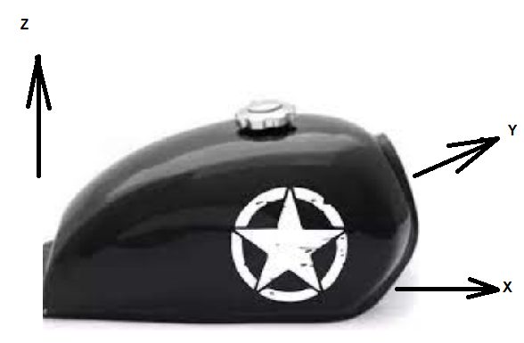  Figure 1 | [3]
Q.3 | Analyze the mechanism given in the figure and determine the degrees of freedom.  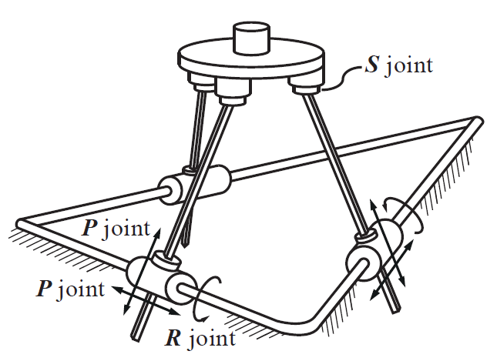  Figure 2 | [4]
Q. 4 | Assign the coordinate frames and write the forward kinematics equation for the 6 dof manipulator for the shown home position (figure 3), Write the equations for $T_{0}^{1}$, $T_{1}^{2}, T_{2}^{3},$ $T_{3}^{4},$ $T_{4}^{5}$ and$T_{5}^{6}$. (General Equations are sufficient - Matrix Expansion is not required).  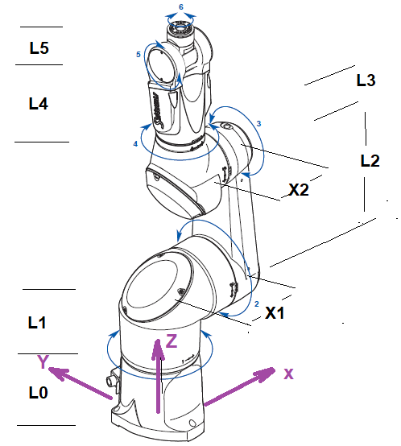  Figure 3 | [8]
Q. 5 | How is a drive system selected while designing a robot? | [2]
Q. 6 | List the steps in using a polygon to determine the Chebyshev’s spacing of n number of accuracy points. Comment of the spacing of the points. | [2]
Q.7 | Find the variables θ1, θ2 and d3 for the given arm for the target point P (650,250,350), if X1= 100mm X2 = 150mm, L1 = 400mm.  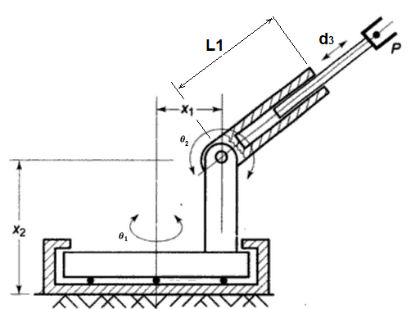  Figure 4  ********* | [8]

